Relax and reflect…

Enjoy reflecting/thinking about yourself while you look at the bubbles and colours.

What kind of person are you?

What are your strengths?

(If you can see any of your strengths on the post-cards, you can read the back if you like…)

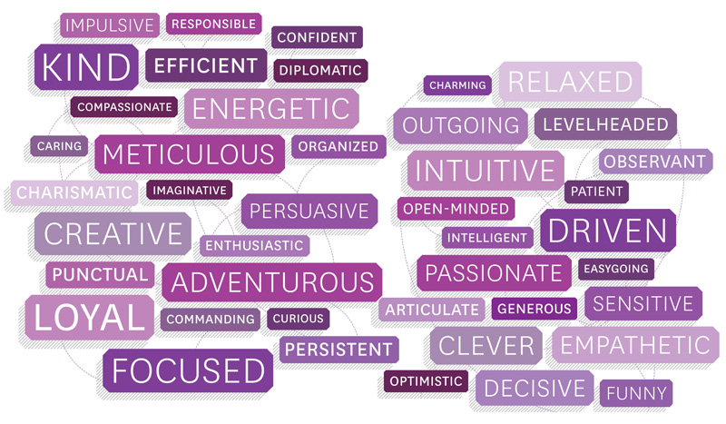

Who am I? What do I enjoy most?

What type of person do I want to be?

Where does my identity come from?