The Wonder of Creation

[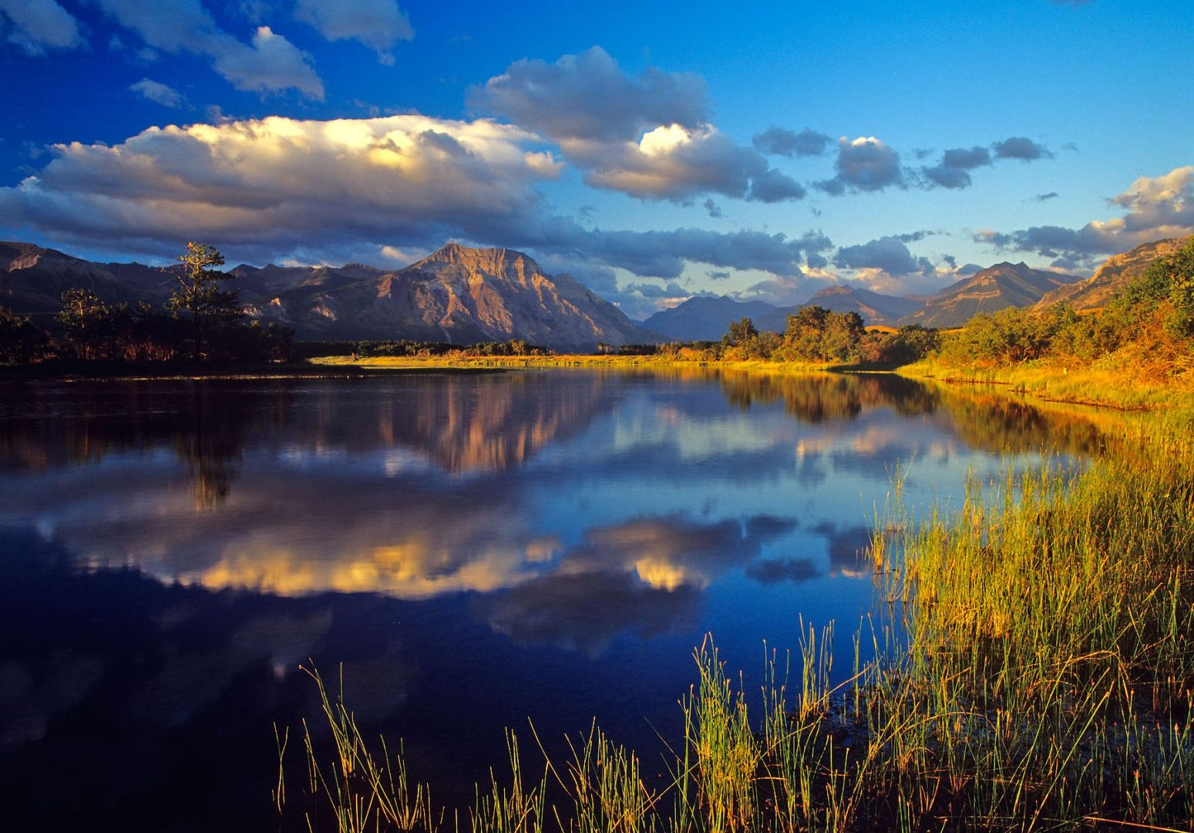](http://wpnature.com/wp-content/uploads/2016/11/lakes-lake-late-summer-beautiful-reflection-clouds-copy-desktop-wallpapers-amazing-collection.jpg)

Enjoy watching the images on the screen

to help you *reflect* on the wonders of creation.

We live in a beautiful world and it’s good to take time to stop and enjoy nature and creation.

Think about how it makes you feel ? How could you describe what you see/feel ?

If you like, you could write or draw a response to

looking at the images and enjoying our amazing planet.