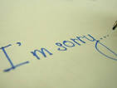

Think about something you are sorry for or regret doing or saying or thinking.

Write or draw it on the special paper.

You could say “Sorry” to God if you want. He will always forgive you.

Then gently place the paper in the bowl of water and watch your image disappear

– you can stir the water with the spoon.

This shows the idea that God forgives the wrong things we have done.

Forgiving means choosing to let go.