Pupil premium strategy statement for All Saints’ Junior School, Warwick
This statement details our school’s use of pupil premium funding to help improve the attainment of our disadvantaged pupils.
It outlines our pupil premium strategy, how we intend to spend the funding in this academic year and the outcomes for disadvantaged pupils last academic year.

School overview
Detail | Data
School name | All Saints’ CE Junior School, Warwick
Number of pupils in school | 222
Proportion (%) of pupil premium eligible pupils | 24%
Academic year/years that our current pupil premium strategy plan covers (3 year plans are recommended) | 2025/26 – 2028/29
Date this statement was published | December 2025
Date on which it will be reviewed | December 2026
Statement authorised by | Jon Queralt
Pupil premium lead | Jon Queralt
Governor lead | Jody Tracey

Funding overview
Detail | Amount
Pupil premium funding allocation this academic year | £83,225
Pupil premium funding carried forward from previous years (enter £0 if not applicable) | £0
Total funding | £83,225

Part A: Pupil premium strategy plan

Statement of intent
Our ambition is for every child at All Saints’ to flourish academically, socially and emotionally. We place high-quality teaching at the heart of our strategy and ensure that the learning experiences of disadvantaged pupils are shaped by strong assessment, early intervention, and a consistent whole-school commitment to inclusion.
Our intention is that all pupils, irrespective of their background or the challenges they face, make good progress and achieve high attainment across all subject areas. The focus of our pupil premium strategy is to support disadvantaged pupils to achieve that goal, including progress for those who are already high attainers.
We will consider the challenges faced by other vulnerable pupils, such as those who have a social worker and/or are young carers. The activities we have outlined in this statement are also intended to support their needs, regardless of whether they are disadvantaged or not.

High-quality teaching is at the heart of our approach, with a focus on areas in which disadvantaged pupils require the most support. This is proven to have the greatest impact on closing the disadvantage attainment gap and at the same time will benefit the non-disadvantaged pupils in our school. Implicit in the intended outcomes detailed below, is the intention that non-disadvantaged pupils’ attainment will be sustained and improved alongside progress for their disadvantaged peers.

Our approach will be responsive to common challenges and individual needs, rooted in robust diagnostic assessment, not assumptions about the impact of disadvantage. The approaches we have adopted complement each other to help pupils excel. To ensure they are effective we will:
- ensure disadvantaged pupils are challenged in the work that they’re set
- act early to intervene at the point need is identified
- adopt a whole school approach in which all staff take responsibility for disadvantaged pupils’ outcomes and raise expectations of what they can achieve
- All children should and will benefit from the teaching and learning opportunities that PP funding provides
- Appropriate provision is made for all pupils belonging to vulnerable groups, including those who are from socially and economically disadvantaged groups.
- PP spending should be allocated following a needs analysis which identifies children with priority needs; those with the greatest need being children in receipt of free school meals whose progress is not rapid enough.
- Pupils who receive free school meals are not necessarily socially disadvantaged or are making inadequate progress.
- Not all pupils who are socially disadvantaged are registered or qualify for free school meals.
- Our PP funding should be spent in a wide and imaginative variety of ways, to benefit the wide variety of interests and needs of our children
- Our PP funding should be spent according to ‘best value principles’ and related to activities which research suggests will make the very best use of the finances available
- Whilst there are some ‘quick wins’, there is a need to also take a ‘long term view’ to stop achievement gaps from widening. Some of our long-term objectives will take more than an academic year to come to fruition.

Attendance of Disadvantaged Pupils:
All Saints’ average attendance is 95.6%, placing the school 111th out of 196 of our LA schools.
Attendance for pupils eligible for PP is 92.6%, ranked 117th out of 196 “ “ “ “
For pupils with SEND it is 94.0%, “ 114th “ “ 196 “ “ “ “

In national comparison terms, this positions the school in the 6/10 attendance decile 6/10 overall, PP decile 7/10, and SEND decile 6/10—indicating broadly mid-to-upper performance nationally, with disadvantaged attendance the key relative pressure point.

Historically, there have been greater differences in attendance patterns; through careful monitoring and effective support for the children, overall rates of absence and that of persistent absence are now more in line. These will continue to be carefully monitored, with strategies implemented at the earliest opportunity if required.

Challenges

This details the key challenges to achievement that we have identified among our disadvantaged pupils.
Challenge number | Detail of challenge
 | Assessments, observations, and discussions with pupils indicate underdeveloped oral language skills and vocabulary gaps among many disadvantaged pupils. These gaps are evident on entry to Reception at our federated Infant school, with gaps persisting throughout KS2. In general, these gaps are more prevalent among our disadvantaged pupils than their peers.
2. | Assessments, observations, and discussions with pupils suggest disadvantaged pupils generally continue to experience greater difficulties with phonics on entry to KS2, than their peers. This negatively impacts their development as readers.
3. | Assessments and observations indicate that disadvantaged pupils make less progress and attainment in writing by the end of KS2. This is attributed to a combination of factors – oracy skills are not as strong as non-disadvantaged peers; transcription skills are not fully secured by the end of LKS2; this means that chn have a greater cognitive load when carrying out more complex writing tasks in UKS2.
4. | Internal and external (where available) assessments indicate that maths attainment among disadvantaged pupils is significantly below that of non-disadvantaged pupils, with this gap remaining steady to the end of KS2. Disadvantaged pupils generally underachieve on the Y4 Multiplication Tables check (MTC) – this lack of fluency has a significant impact on further development and attainment in maths.
5. | Our assessments, observations and discussions with pupils and families have identified social, emotional and mental health difficulties for many pupils. These challenges particularly affect disadvantaged pupils, including their academic attainment and progress.

Intended outcomes
This explains the outcomes we are aiming for by the end of our current strategy plan, and how we will measure whether they have been achieved.
Intended outcome | Success criteria
Improved oral language skills and vocabulary among disadvantaged pupils.  75% of disadvantaged pupils to meet age-related expectations for oracy by end of KS2 | Assessments and observations indicate significantly improved oral language among disadvantaged pupils. This is evident when triangulated with other sources of evidence, including engagement in lessons, book scrutiny and ongoing formative assessment.
Sustain improved reading attainment among disadvantaged pupils.  Attainment for PP and non-PP to remain in-line at the end of KS2 (see outcomes in Part B) | Internal assessments indicate similar rates of progress from starting points for disadvantaged pupils and their peers.  KS2 reading outcomes in 2024/25 show that non-SEN disadvantaged pupils meet the expected standard.
Improved outcomes in writing among disadvantaged pupils.  60% of PP children to achieve EXS in writing at the end of KS2 (in-line with national for 2025) | A revised ‘Writing Process at All Saints’ was introduced in January 2025; focus is on reducing the cognitive load for writing by slowing down the process and including a greater focus on securing transcription skills by the end of lower KS2.
Improved maths attainment for disadvantaged pupils at the end of KS2.  60% of PP children to achieve EXS in maths at the end of KS2 (in line with national for 2025)  Y4 MTC: Reduce the gap from 3.7 to 2 points between PP and non-PP children. | Internal assessments indicate similar rates of progress from starting points for disadvantaged pupils and their peers.  Increased fluency with number, especially rapid recall with times tables facts, enables better outcomes.  KS2 maths outcomes in 2024/25 show that non-SEN disadvantaged pupils meet the expected standard.
To achieve and sustain improved wellbeing for all pupils in our school, particularly our disadvantaged pupils. | Sustained high levels of wellbeing from 2024/25 demonstrated by:  - qualitative data from pupil and parent questionnaires and teacher observations  Qualitative and quantitative data from behaviour reports indicating:  - reduction in the number of reports  - reduction in the number of persistent difficulties;  Embedded use of the Zones of Regulation approach enables pupils to self-regulate using appropriate strategies.

Activity in this academic year
This details how we intend to spend our pupil premium (and recovery premium funding) this academic year to address the challenges listed above.

Teaching (for example, CPD, recruitment and retention)
Budgeted cost: £16,000
Activity | Evidence that supports this approach | Challenge number(s) addressed
Time allocated for teaching and support staff to implement standardised assessments. | Standardised tests can provide reliable insights into the specific strengths and weaknesses of each pupil to help ensure they receive the correct additional support through interventions or teacher instruction:  Standardised tests | Assessing and Monitoring Pupil Progress | Education Endowment Foundation | EEF | 1, 2, 3, 4
Embedding dialogic activities (the use of conversation or shared dialogue to explore the meaning of something) across the school curriculum. These can support pupils to articulate key ideas, consolidate understanding and extend vocabulary.  We will purchase resources and fund ongoing teacher training and release time. | There is a strong evidence base that suggests oral language interventions, including dialogic activities such as high-quality classroom discussion, are inexpensive to implement with high impacts on reading:  Oral language interventions | Toolkit Strand | Education Endowment Foundation | EEF  https://www.gov.uk/government/publications/subject-report-series-english/telling-the-story-the-english-education-subject-report | 1, 3
Enhancement of our maths teaching and curriculum planning in line with DfE and EEF guidance.  We will fund teacher release time to embed key elements of guidance in school and to access Maths Hub resources and CPD; Two of our TAs are engaged in a programme of CPD across the 25/26 academic year. | The DfE non-statutory guidance has been produced in conjunction with the National Centre for Excellence in the Teaching of Mathematics, drawing on evidence-based approaches:  Maths_guidance_KS_1_and_2.pdf (publishing.service.gov.uk)  The EEF guidance is based on a range of the best available evidence:  Improving Mathematics in Key Stages 2 and 3 | 3
Improve the quality of social, emotional and mental health (SEMH) learning.  SEMH approaches will be embedded into routine educational practices and supported by professional development and training for staff.  This will include allocated time for designated Senior Mental Health Lead (Sandra Sutherland) to carry out role as Mental Health First-aider & attend Educational Psychology service facilitated Mental Health Network and associated training & conferences | There is extensive evidence associating childhood social and emotional skills with improved outcomes at school and in later life (e.g., improved academic performance, attitudes, behaviour and relationships with peers):  EEF_Social_and_Emotional_Learning.pdf(educationendowmentfoundation.org.uk) | 5

Targeted academic support (for example, tutoring, one-to-one support structured interventions)
Budgeted cost: £37,725
Activity | Evidence that supports this approach | Challenge number(s) addressed
Implementation of a programme to improve listening, narrative and vocabulary skills for disadvantaged pupils who have relatively low spoken language skills. Cost of TA delivery time. | Oral language interventions can have a positive impact on pupils’ language skills. Approaches that focus on speaking, listening and a combination of the two show positive impacts on attainment:  Oral language interventions | EEF (educationendowmentfoundation.org.uk) | 1, 3, 5
Additional phonics sessions targeted at disadvantaged pupils who require further phonics support.  RWI 1:1 phonic tuition will be used to link phonics knowledge, applying to reading and linking to written outcomes. | Phonics approaches have a strong evidence base indicating a positive impact on pupils, particularly from disadvantaged backgrounds. Targeted phonics interventions have been shown to be more effective when delivered as regular sessions over a period up to 12 weeks:  Phonics | Toolkit Strand | Education Endowment Foundation | EEF  Staffing costs for these sessions | 2, 3

Wider strategies (for example, related to attendance, behaviour, wellbeing)
Budgeted cost: £29,500
Activity | Evidence that supports this approach | Challenge number(s) addressed
Sustaining the role of Senior Mental Health Lead (as before), co-ordinating SEMH and other well-being measures.  Train TAs to support with delivery of mental health provision. Cost of release time to attend Mental Health First aid briefings. | Social and emotional learning (SEL) interventions seek to improve pupils’ decision-making skills, interaction with others and their self-management of emotions, rather than focusing directly on the academic or cognitive elements of learning.  SEL interventions might focus on the ways in which students work with (and alongside) their peers, teachers, family or community.  https://educationendowmentfoundation.org.uk/education-evidence/teaching-learning-toolkit/social-and-emotional-learning | 5
Employing school counsellor to support SEL  Funding of a Family Link Worker –between school and church – who provides SEMH support, including delivery of Drawing and Talking therapy. | https://educationendowmentfoundation.org.uk/education-evidence/teaching-learning-toolkit/social-and-emotional-learning | 5
The use of Zones of Regulation  has been implemented across school and the success of this needs to be sustained. The ongoing aim is to further develop our school ethos and improve behaviour across school. | Both targeted interventions and universal approaches can have positive overall effects:  Behaviour interventions | EEF (educationendowmentfoundation.org.uk) | 5
Contingency fund for acute issues. | Based on our experiences and those of similar schools to ours, we have identified a need to set a small amount of funding aside to respond quickly to needs that have not yet been identified. | All
Funding for well-being activities | Funding of sports, music, drama and other related extra-curricular activities for disadvantaged chn. | 5

Total budgeted cost: £ 83,225
The impact of pupil premium funded activity will be reviewed termly through pupil progress meetings, analysis of assessment data, attendance and behaviour monitoring, and evaluation of intervention outcomes. This ensures provision is adjusted swiftly where impact is limited.

Part B: Review of outcomes in the previous academic year

Pupil premium strategy outcomes
This section reviews the impact of pupil premium spending in the 2024–25 academic year, which directly informs the strategy for 2025–26 onwards
For the academic year 2024 – 25, we continued to employ additional TA hours to increase the range and number of children who could be supported in catching up via interventions. This included SEMH support in addition to academic interventions. We have also funded all TAs to support at break and lunchtimes, providing SEMH and behaviour regulation support during those unstructured times of day.
Our assessments and observations indicated that pupil wellbeing and mental health continue to be of great concern, with impact being particularly acute for disadvantaged pupils and their families. We use pupil premium funding to continue with the provision of wellbeing support for all pupils, and targeted interventions where required. We are building on that approach with the activities detailed in this plan.
2024-25 Review of Intended Outcomes:
Academic Outcomes:
End of KS2 results for 2024-25 cohort; % of chn achieving EXS:
 | School  (6 chn) | L.A. | National
Reading | 67% | 58%  (School +9%) | 63%  (School + 4%)
Maths | 33% | 53%  (School -20%) | 61%  (School -28%)
GPAS | 67% | 56%  (School +11%) | 60%  (School +7%)
Writing (TA) | 33% | 55%  (School -22%) | 60%  (School -27%)
Summary:
The year showed a mixed picture, reflecting high SEND complexity within a small cohort (29 chn, rather than the usual 58):
3 of the 6 children entitled to PP (50%) were SEND; 2 of those children were not entered for the tests as they were working at a pre-key stage level.
There are ongoing strengths in attainment in reading and GPAS, supporting the aim of PP chn being ‘secondary ready’ in these areas.
There continue to be ongoing concerns about attainment in maths and writing. Priorities for next year include stronger focus on early oracy, transcription, and maths fluency, alongside sustained SEMH investment.
Progress measures – from KS1 to KS2
Although not available nationally, as a junior school, we track progress from end of KS1 to end of KS2. This internal data shows:
100% of PP children made expected or greater progress from individual starting points in Reading, Writing and Maths. This is important data for a highly inclusive school with significantly higher levels of SEND than other schools.
Internal data – PP vs Non-PP:
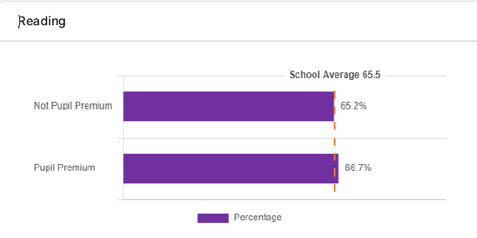
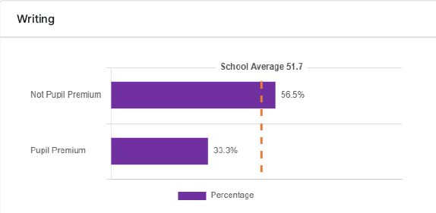
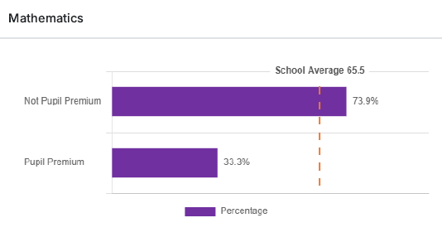
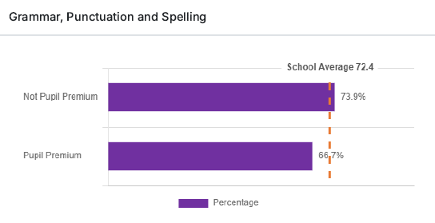
Summary:
Reading – PP chn in line with non-PP (1.5% above non-PP)
Writing – 23.2% gap
Maths – 40.6% gap 6 chn, 3 working below the level of the test, and one achieved scaled score of 99, so very close to EXS (100). This child had achieved EXS on prior tests but not on the day.
GPAS – 7.2% gap
Again, there are ongoing strengths in narrowing the gap internally between PP & non-PP in reading and GPAS, supporting the aim of PP chn being ‘secondary ready’ in these areas.
As before, there continue to be ongoing concerns about attainment in maths and writing. Priorities for next year include stronger focus on early oracy, transcription, and maths fluency, alongside sustained SEMH investment.
Y4 MTC check
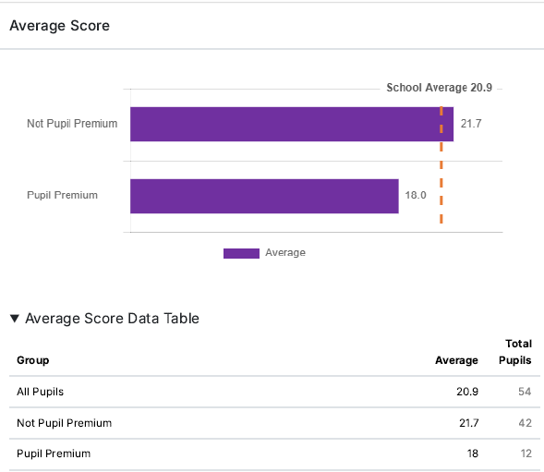
Gap of 3.7 points between PP and non-PP.
SEMH outcomes:
- 18 children received Drawing & Talking therapy; 100% improved on emotional wellbeing, measured using SDQ questionnaires; all moved from very high or high scores at outset to scores close to average.
- Family Link Worker provided ongoing family support.
- Improved readiness to learn for SEMH-supported pupils.
- Reduction in number of children moving through the behaviour management process, leading to fewer detentions. 10% reduction in 2024-25 vs 2023-24.

