Times Tables Challenge

Dear Parents and Carers,

This half term we have started a whole school push on ensuring all children know their times-tables. To this end we have introduced a 10-minute daily session around a selection of facts. This aims to help children learn the facts and become more confident around calculating within multiplication and division across the curriculum.

Part of our strategy in school is to identify and reduce the amount of facts that the children need to know, in order to become more successful at mentally calculating.

We do this by:

- Teaching the children to read a calculation with the largest number first – for example 3 x 5 would be read and learnt as “five threes are ….” This is due to the fact that multiplication calculations can be completed in any order and give the same result (commutativity)

- This allows us to remove a large section of facts because if we know 4 x 5 = 20 then we also know and don’t need to learn 5 x 4 = 20.

- We will also be linking division representations in the sessions by reading those as multiplication. For example: 18 ÷ 6 = 3 would be read out loud as “six threes are eighteen”

FACTS TO LEARN:
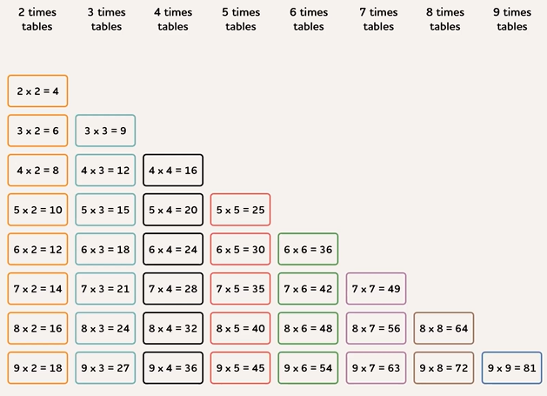

On top of the daily sessions your child has in school, we would like you to spend 10 minutes a day four times a week learning them. When your child has completed four sessions, please sign a raffle ticket and let them bring it in.

We will celebrate all of this hard work by drawing out lucky tickets to win some great prizes.
At the end of the term.

Ways to recall times tables:

- Hit the button: https://www.topmarks.co.uk/maths-games/hit-the-button
(When learning a table a score of 20 correct in 1 game (1min long) lets you know your child is developing quick recall.)

- You can make cards to help the children recall facts – only focus on a few at a time until the children are secure and then add in more cards.
- Learn them in the car
- play first to recall them
- write them out

For some children learning timetables is hard, it is the time and repetition that will help them. Please support your child as much as possible with this key life skill.

Kind regards

AS School

FACTS TO LEARN

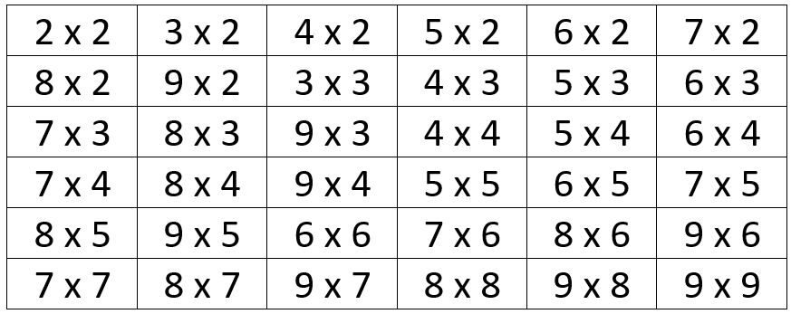

RAFFLE TICKET - Week 1  This week  ______________________  in __________  4  has practised their tables facts times this week | RAFFLE TICKET - Week 2  This week  ______________________  in __________  4  has practised their tables facts times this week
RAFFLE TICKET - Week 3  This week  ______________________  in __________  4  has practised their tables facts times this week | RAFFLE TICKET - Week 4  This week  ______________________  in __________  4  has practised their tables facts times this week
RAFFLE TICKET - Week 5  This week  ______________________  in __________  4  has practised their tables facts times this week | RAFFLE TICKET - Week 6  This week  ______________________  in __________  4  has practised their tables facts times this week

