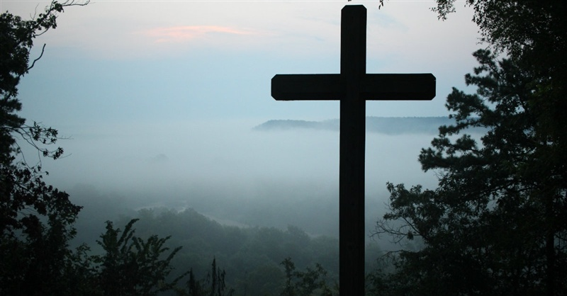

The cross is a symbol of forgiveness and hope because Jesus died to save people and bring them back to God.

You can pray about anything…hopes, worries, thanks, forgiveness.

If you like, write your prayer on a piece of paper, roll it up and push it in to the holes in the cross, as if you’re giving it to Jesus.

It is private, just between you and God.